Mesh exposure after mid-urethral slings: a national cohort study
Maria Ferm Eisenhardt, Niels Klarskov, Thomas Bergholt, Kim Oren Gradel, Karen Ruben Husby
Introduction
Exposure of the sling-material is a rare, however important, complication after mid-urethal slings (MUS). Mesh complications might be related to inflammation and infection, but consensus about prophylactic use of perioperative antibiotics is lacking. Therefore, we aimed to investigate how a single dose of perioperative antibiotics affected the risk of mesh exposure. Furthermore, we wanted to compare the rates of mesh exposure after Retropubic MUS (R-MUS) versus trans-Obturator MUS (tO-MUS).
Methods
We conducted a nationwide cohort study including all Danish women undergoing primary MUS during 2010-2018 and followed them until December 31, 2018.
We applied Cox regressions to compare women who received perioperative antibiotics with those who did not and further to compare women who underwent R-MUS versus tO-MUS.
We wished to determine whether a single dose of perioperative antibiotics affected the risk of mesh exposure. We stratified for type of sling and adjusted for age, disposable income, educational level, smoking habits, alcohol consumption, and American Society of Anesthesiologist’s (ASA) score. To investigate the risk of mesh exposure after R-MUS versus tO-MUS we furthermore adjusted for use of perioperative antibiotics.
Results
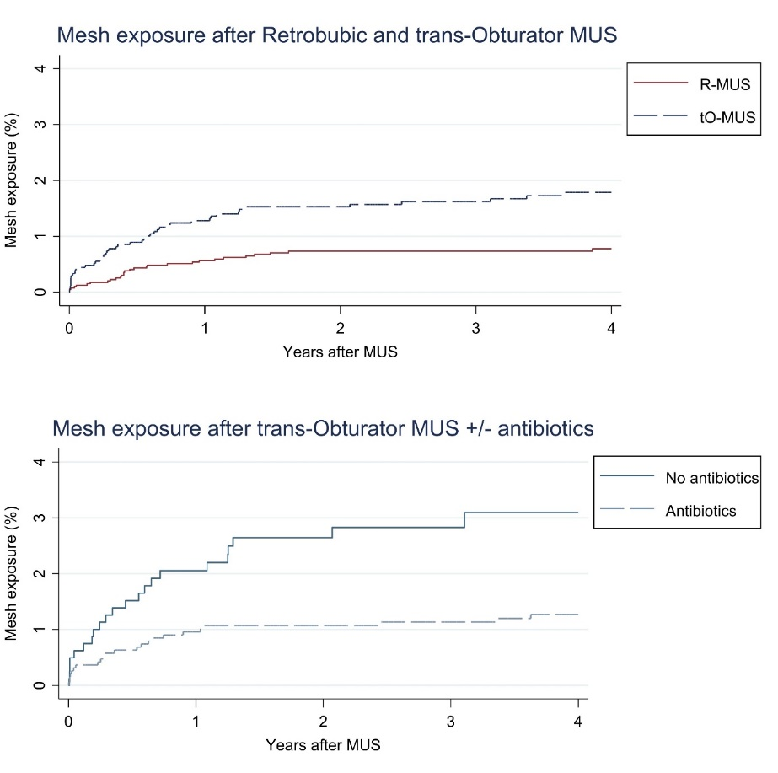
Totally 3,991 women underwent R-MUS surgery and 2,715 underwent tO-MUS surgery.
We found a significantly lower risk of mesh exposure for the women undergoing R-MUS (HR 0.4 [95% confidence interval (CI) 0.3-0.6]). Of the women undergoing tO-MUS, the risk of mesh exposure was significantly lower after receiving perioperative antibiotics (HR 0.4 [95% CI 0.3-0.8]).
Conclusion:
Perioperative antibiotics seem to reduce the risk of mesh exposure after tO-MUS.

