# NSSM Scientific meeting October 27, 13.00 – 16.00 CET

## This year´s topic: Sexual pain

The board of NSSM has the pleasure to invite all professionals in the field of sexology to an interesting afternoon on line.

To achieve the link to the meeting you must register by mail to [admin@nssm.dk](mailto:admin@nssm.dk) . Attendance is free – nonmembers are also welcome and hopefully they will be inspired to apply for memberships.

We have decided to cast light on sexual pain from many angles: female, male, patient or partner by a multidisciplinary group of distinguished speakers from the Nordic countries. The afternoon will be in English.

The lectures will be recorded and are available for 14 days for attendees whereafter they will be deleted.

## The program

13.00 – 13.05 Welcome, introduction by chair person MD, gynecologist Astrid Højgaard, (DK)

13.05 – 13.35 Helena Hallencreutz Grape, physiotherapist, (S). Pain from a physiotherapist point of view.

13.35 – 14.05 Ida Flink , psychologist (S). Pain psychology.

14.05 – 14.45 Charlotte Forstrøm, MD, head of Dept. of Functional Disorders. Pain as a function. Also participating in this talk: Malene L Neesgaard, psychologist and Amanda Legarth, physiotherapist.

Break

14.55 – 15.25 Majken Højrup Wiborg, urologist. Urological causes of sexual pain in men.

15.25 – 15.55 Christina Damsted Pedersen, gynecologist. Vulvar pain.

15.55 – 16.00 Wrap up

## Biographies:

## Biographies:

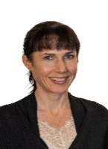**Ida Flink**

Professor in Psychology, Karlstad University

Lic. Psychologist and pain researcher working with CBT for chronic pain,

including vulvodynia.

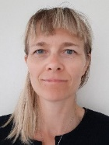**Majken Højrup Wiborg**

Master in Sexology, FECSM,

Specialist in Urology, senior consultant, Esbjerg, Denmark

Worked in urology for 15 years

Currently PhD student doing research in Peyronie´s disease.

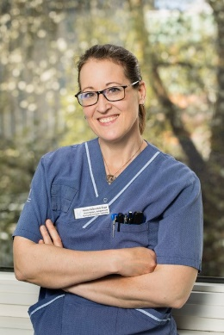

**Helena Hallencreutz Grape**

MSc, Physiotherapist specialized in pelvic floor health, Urotherapist

Karolinska University Hospital, Sweden

PhD student, Karolinska Institutet. Researching chronic pelvic floor pain in men.

**Christina Damsted Petersen**

**P**rivate practice, gynecology, Copenhagen, Denmark

MD, Ph D, theme: The effect of Botox on Vulvodynia

Sexual Counsellor

Board member ECSVD (European Society for the study on Vulvar Diseases)

**Charlotte Forstrøm**

MD, Head of Center for Functional Disorders, Aalborg University Hospital, Denmark

Specialist in Family Medicine. Large experience in Social Medicine.

**Malene L. Neesgaard**

Psychologist in Center for Functional Disorders, Aalborg Universitetshospital, Denmark

Large experience in Social Medicine.

**Amanda Legarth**

Physiotherapist in Center for Functional Disorders, Aalborg University Hospital, Denmark.